Master Servicing Release Notes

June 30, 2020
Effective July 1, 2020, the Fannie Mae Master Servicing Platform will implement changes to support policy updates announced in Lender Letter LL-2020-07 COVID-19 Payment Deferral, published on May 13, 2020 and Lender Letter LL-2020-05 Payment Deferral, published on March 25, 2020. Two new retention workout options were jointly developed with Freddie Mac, at the direction of the Federal Housing Finance Agency (FHFA), for homeowners who have resolved financial hardship but are not able to reinstate or set up a repayment plan. Review the payment deferral matrix to learn more about the two options.
The following updates are included in this release:
- Updates to Fannie Mae Investor Reporting System
- Updates to the Loan Servicing Data Utility (LSDU) User Interface (UI)
- Updates to Fannie Mae Connect Reports

Updates to the Fannie Mae Investor Reporting System
Loan activity reporting must continue on a delinquent mortgage loan that is subject to a COVID-19 payment deferral and payment deferral. Servicers must report delinquency status information to Fannie Mae through our servicing solutions system in accordance with D2-4-01, Reporting a Delinquent Mortgage Loan to Fannie Mae.
For COVID-19 payment deferral, servicers must report a Loan Activity Record (LAR) in the month of evaluation (or in the processing month, if applicable) at least one business day prior to completing a COVID-19 payment deferral in in Fannie Mae’s servicing solutions system.
For payment deferral, servicers must report a LAR with the borrower’s full monthly contractual payment due in the month of evaluation (or in the processing month, if applicable) at least one business day prior to completing a payment deferral in Fannie Mae’s servicing solutions system.

Reference Fannie Mae Servicing Guide for more details on reporting changes.
Updates to the LSDU User Interface (UI)
With this release, LSDU users will be able to view the Mod Program Type “Payment Deferral No Reclass Program 1 to 12 months” for COVID-19 payment deferral and “Payment Deferral No Reclass Program” for Payment Deferral in the Delinquency Modification Data section of LSDU. See screenshots below.

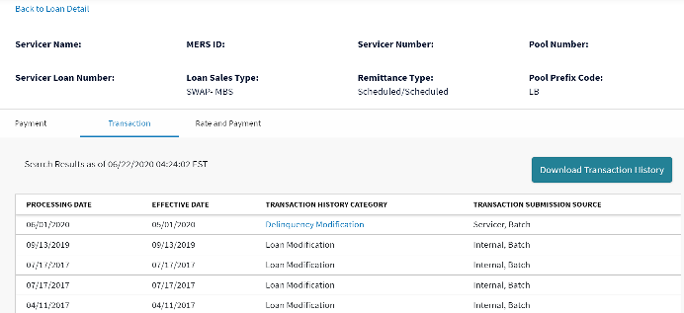
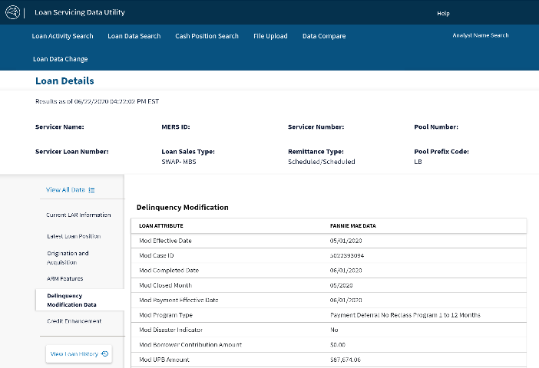
COVID-19 Payment Deferral

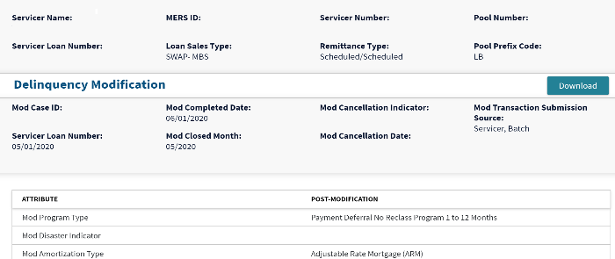

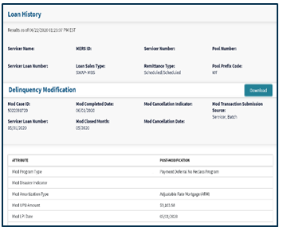
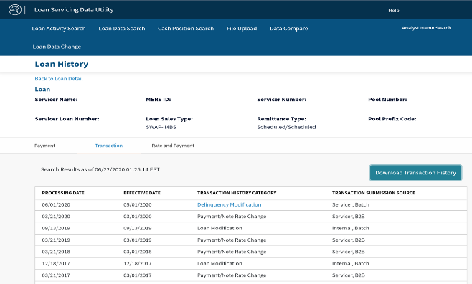
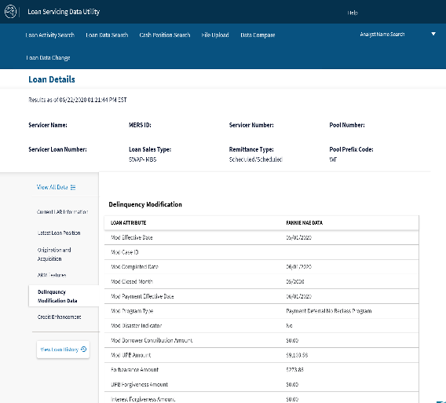
Payment Deferral

Updates to Fannie Mae Connect Reports
With this release, Fannie Mae Connect users can determine closed and cancelled payment deferrals by accessing the following Fannie Mae Connect Reports:
New Report Name | Former Report Name | Usage | Payment Deferral Identification | COVID-19 Payment Deferral Identification
DARTS Delinquency Modification and Payment Deferral Closed Report | DARTS Closed Modification | This report contains modifications and payment deferrals that successfully closed in Fannie Mae's Servicing Solution System and bridged over to Fannie Mae's Servicing and Investor Reporting (SIR) system for the specified month. | Payment Deferral No Reclass Program (Del Mod Program) | Payment Deferral No Reclass Program 1 to 12 months
Delinquency Modification and Payment Deferral Cancellations | Del Mod Cancellation | This report contains modifications and payment deferrals that cancelled in Fannie Mae's Servicing Solution System requiring case cancellations in Fannie Mae's Servicing and Investor Reporting (SIR) system for servicer's portfolio. | Program type not identified on report; go to LSDU Delinquency Modification Data tab to view Mod Program Type | Program type not identified on report; go to LSDU Delinquency Modification Data tab to view Mod Program Type
Delinquency Modification and Payment Deferral Failed Business Rules | Delinquency Modification Failed Business Rules | This report is used to identify corrections needed for delinquency modifications and payment deferrals not updated by Fannie Mae's Servicing and Investor Reporting (SIR) system due to failed business rules. | Program type not identified on report; go to LSDU Delinquency Modification Data tab to view Mod Program Type | Program type not identified on report; go to LSDU Delinquency Modification Data tab to view Mod Program Type
S/S Delinquency Modification and Payment Deferral P&I Advance Reimbursement Report | Delinquency Modification SS Cash P and I Reimbursement Report | This report notifies servicers of reimbursed delinquent P&I advances for delinquency modifications and payment deferrals, as well as, funds that will be drafted from the servicer' s account when a transaction is cancelled. | Program type not identified on report; go to LSDU Delinquency Modification Data tab to view Mod Program Type | Program type not identified on report; go to LSDU Delinquency Modification Data tab to view Mod Program Type

More Information
For more information about this release, please email Future of Servicing or contact Master Servicing at 1-800-2- FANNIE (Option 1, Option 6).

Other helpful resources:

Servicing Learning Center
Fannie Mae Connect Help Center
Lender Letter LL-2020-07 COVID-19 Payment Deferral
Lender Letter LL-2020-05 Payment Deferral
Payment Deferral Matrix
Impact of COVID-19 on Servicing

